How to Create Your Own Blog!

Tired of the old fashion journal writing with a leaky ink pen and a scrap notebook that falls apart at a simple touch? Those old fashion journals are a thing of the past, especially with the new technology of internet blogs. What’s a blog you ask? A blog is an internet journal where people all over the world can write their thoughts, tell others what’s happening in their lives, or maybe even use them to stalk other people (okay just kidding on that one). Anyone can create a blog, even if you don’t have much technological experience. Don’t be intimidated either. You don’t have to be an artist or writer to have a blog.
With the use of online journals these days, it’s about time someone showed you how to create your own. Since blogging is an up and coming writing practice people are designing their own blogs through many different mediums (websites that let you create blogs). Are you ready for your own blog? If you answered yes then these instructions are just for you! With these instructions you will learn how to create your own blog through blogger.com. These instructions will walk you through the basic set-up of creating your blog and will help you become more familiar with blogs in general. However, because there is a lot to learn with blogs, these instructions will only take you through the basics, the more advanced stuff will come in time.

What will these instructions teach me?

- How to access blogger.com
- How to create your very own blog in three easy steps
- How to write a post (a technical term for writing something on your blog)
- How to sign in and sign out of your blog
- How to view your blog and share it with others

Do I need these instructions?

- If you thought a blog was a traditional Spanish custard, then yes you need these instructions
- If you have never used blogs before, then yes you need these instructions
- If you sort of know how to use a blog but want to increase your blogging knowledge, then yes you need these instructions
- If you have mastered blogging, but have been on vacation for more than a year and want a refresher, then yes you need these instructions

Do I need any background information?

- You need to know how to connect to the internet explorer or the internet service provider you have
- You need to know the basic uses of the internet
- If you don’t know how to turn on a computer, then there are a different set of directions out there for you…find them quick!

So I really want one of these Blog things…what do I need to get one?

- All you need is simply a PC or a MAC computer with internet connectivity
- A mouse and keyboard might help (yes, you’ll need the keyboard in order to type a post)
- An e-mail account and a valid e-mail address

Got my computer, internet, and keyboard; what’s next?

How to Access Blogger.com

- The first thing you need to do in order to get started is get on the internet. For those of you who have dial up, connect through your normal connection. Those of you who have broadband or LAN (meaning you are always connected) open up the internet explorer.
- In the address bar of the internet, type in the flowing address: http://www.blogger.com
  - Don’t know what an address bar is? The flowing screen shows a picture of the address bar as it appears on the internet. On your computer just type the address into this bar and hit “Go.”

How to Create Your Very Own Blog in Three Easy Steps

Once you have gotten to the blogger.com website you will see the following screen displayed below. When you get to this screen you are now ready to follow the instructions on the screen and begin creating a blog of your very own. To begin the set-up process, click the orange arrow “Create Your Blog Now.”

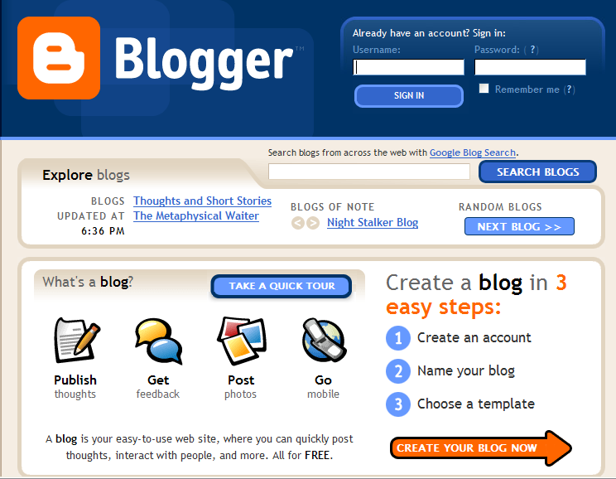
3 Easy Steps to Creating your Blog

1. Create Account

- After you have clicked on the orange arrow, you will see the screen below which will allow you to create an account.

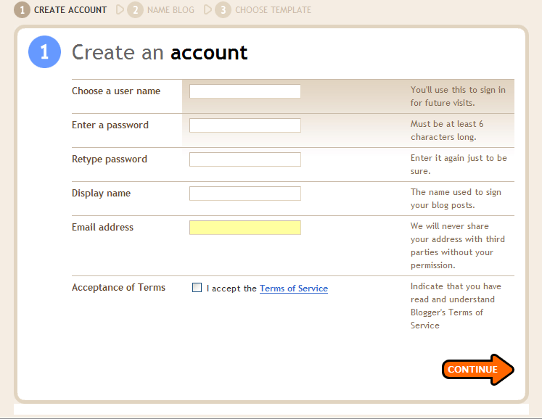

Once you get to the “Create an Account Screen,” you need to enter all the information in each box.

- Create a user name: The user name isn’t the name of your blog. Instead it is the name that you will type in when signing into your blog in order to gain access to your blog when you want to add a post. (i.e. sarahjones22)
- Create a password: Create a password that is preferably not something people would easily guess, and please write it down somewhere…you know you’ll probably forget within an hour!
- Create the display name: This is the name that will appear at the end of each post. If your name is Cindy you may want to stick with that or if you prefer to remain unidentified create an Allis.
- Enter your e-mail address: This is so the company can send you information on your blog.
- Read over the terms and conditions: This site is free, but it’s always good to read over the terms and conditions for anything! Check the box if you agree and let’s get moving!
- Hit the orange arrow to continue.

2. Name Your Blog

After you continue to the next page, the “Name Your Blog” screen will appear. This is demonstrated in the screen below.

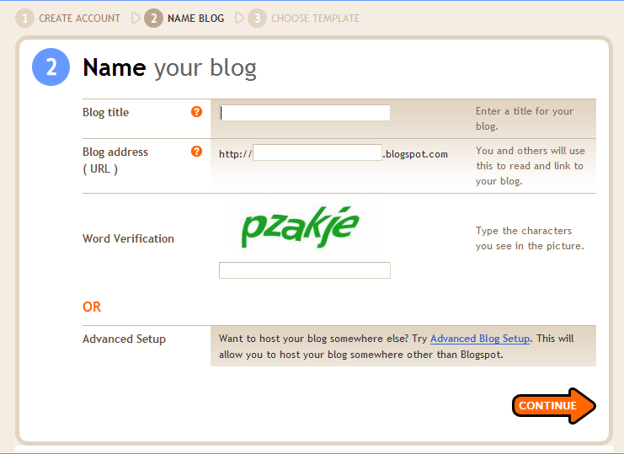

Here in this screen you actually get to unleash the creative side. Yes, that’s right it’s the anticipated time of naming your blog! Yeah! Here you will create a site name (a way for people to identify you). Here are the steps you need to complete this page.

- Enter a title into the box “Blog Title:” This can be something as creative or as simple as you would like it.
    - If you are totally in love with Johnny Depp then you could make your blog name something like InlovewithDepp. There are no spaces allowed, and if you get a screen that comes up saying “this name is not available” it just means that someone else is in love with Johnny Depp and they have already taken this name. You’ll have to come up with another name.
- Enter your blog address: The blog address is what people will type in the address bar (remember that term from earlier) to view your blog. Here you can create any name that you would like. You should preferably stick with the name of your blog or your name so that it easy for people to remember. (i.e. http://InlovewithDepp.blogspot.com)
- Enter the word in green in the word verification box: The word you see in green (sometimes red) needs to be retyped into the word verification box. This is for security purposes for the company and has nothing to do with your blog.
- If you’re brave enough to adventure out of the simplistic world you can try the advanced set-up, but for now we’re just covering the basics, which work just fine!
- After you’re all done, hit the orange arrow and continue on to the last and final step!

3. Choose a Template

Yeah, it’s the last step until you get to view your blog! After naming your blog you will see the screen below. Here you can choose the design temple for your blog. This is the design that will appear on your blog, making it more personal and fun. There are many different templates you can choose from. When you find the template that suits you, select the template and hit the orange arrow to continue.

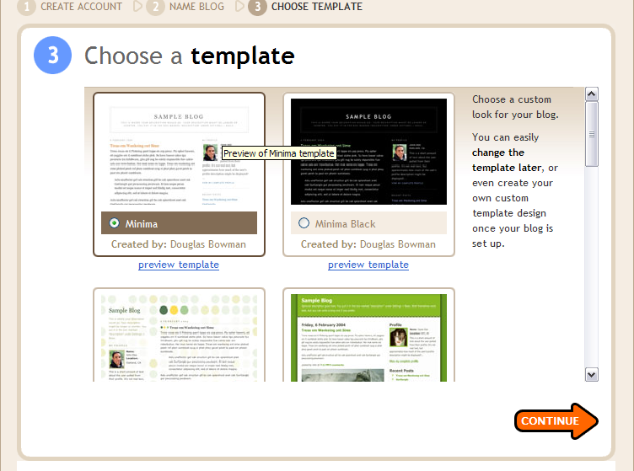

After you choose your template you will see the following screen. Yeah, you’ve done it! Give yourself a pat on the back; you’ve successfully created a blog! Are you ready to begin posting? Once you are ready to post, you can hit the orange arrow (“Start Posting” arrow) and write your very first entry.

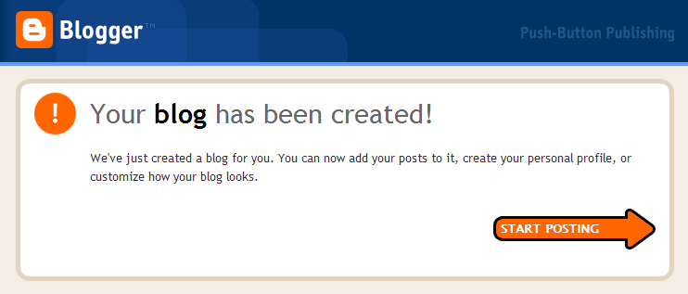

How to Write a Post

To write a post, just select within the text box and start typing away. The posting page is demonstrated in the screen on the next page. You can write about whatever you like: what you did that day, poems, stories, or even surveys about yourself, anything you can think of. (However, be careful and know that your blog is out there on the web, and if you are venting about a situation or someone, they may find it so be careful about sensitive subjects unless you really don’t care).

Font, Colors, Alignment

Within your post you can change the font (the style of the type), the colors, and the alignment (where the text is placed on the page).
- To change the font: click on the font tab (right underneath the title box) and choose you desired font
- To change the size: click on the size tab (right next to the font tab) and choose your desired size
- To change the color: click on the “T” with the color palate (right next to the “i” or italics button) and choose your desired color
- To change the alignment of the text: click on the desired alignment buttons (located right next to the color button)

Date, Time, Titles

- You can also change the date and time of when you posted. To do this simply change the date and the time to what you would like it to say in the “Change Date & Time” boxes toward the bottom of the screen.
- You can also give your post a title (i.e. My Crazy Day). Just type this in the “Title” box. All of these features can be seen in the following screen.

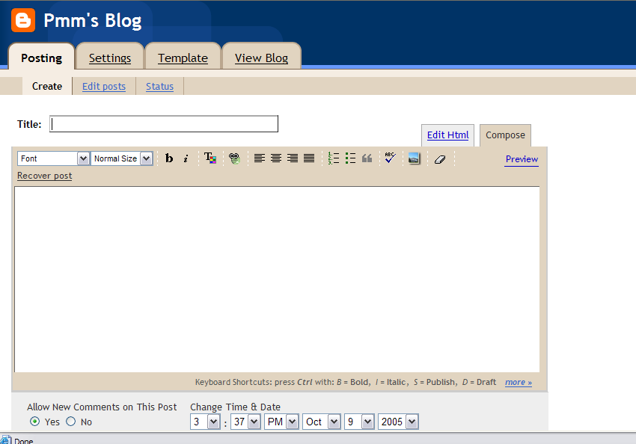

Publishing a post

After you have gotten the post how you want it and have typed all the information you want to say you are now ready to publish it (or put it on your site for others to read).
- To publish a post: To publish it just hit the “Publish Post” button at the bottom of the screen. This is displayed in the screen on the following page.
- To save a post: If you are not ready to publish a post, but don’t want to loose your information, you can hit the “Save as Draft” button. This allows you to save your post as a draft, come back to it later on, and publish it when you are ready. This button can also be seen in the following screen.

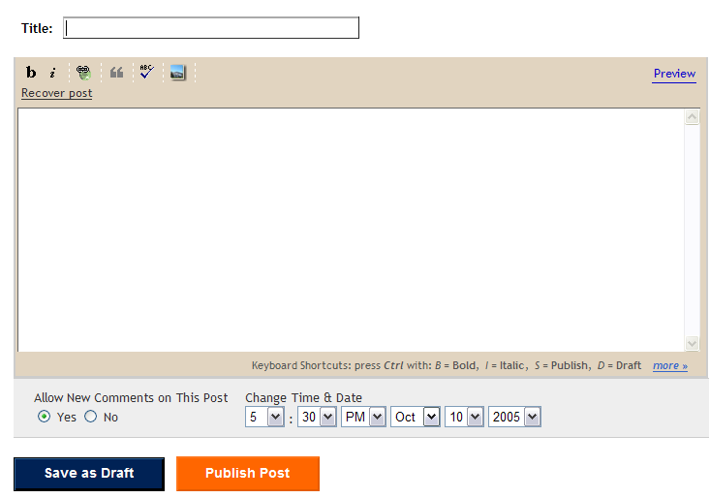

How to Sign In And Out Of Your Blog

After The Initial Set-Up

Once you are done with the initial set-up and have posted your first entry and signed out, you can sign back in again anytime of the day! (That’s what makes blogs great; you can use them at your connivance.) To sign back in follow these steps.

- Type in www.blogger.com into the address bar to arrive at the main site where you can sign in.
- Once you are there you will see the main sign in screen. This is shown in the screen located on the next page.
- In the upper right hand corner there are two boxes that say “Username” and “Password.”
- In the “Username” box, type in the user name that you have created (i.e. sarahjones22)
- In the “Password” box, type in your password that you created (i.e. snowball)
- Then hit the blue “Sign in” button.
- This will take you to a screen displaying the details of your blog where you can post, change settings, edit your profile, and more.

To sign out of your blog, there is a “sign out” button at the top of every screen once you are in your blog. Just hit this button at anytime you want to leave!
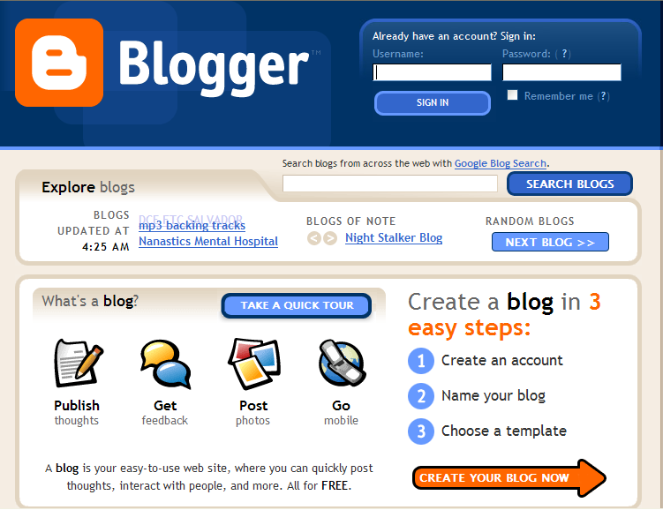

How to View your Blog and Share it With Others

Reading your Blog

To read your blog you need to type in the address to your blog (i.e. http://InlovewithDepp.blogspot.com) into the address bar on the internet. This will take you to your blog so that you can read it. However, you won’t be able to make any changes to your blog unless you sign in. You can also view your post when you are signed in. Hit the “View” tab when you are in the posting window. (See the section on posting for a picture of the “View” tab).

Sharing your Blog with Others

To share your blog with others simply give them the address to your blog (i.e. http://InlovewithDepp.blogspot.com) and they can type that into the address bar in their computer to view your blog. When people are viewing your blog it will look similar to the screen displayed below (your template and posts will be different of course, unless you’re a copycat!)

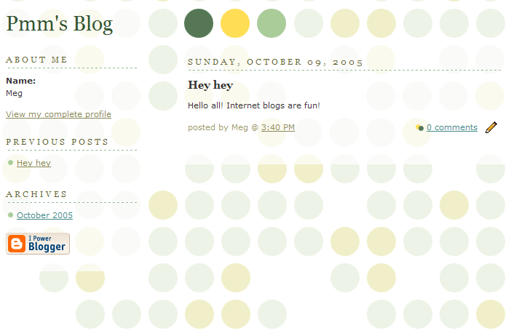

I’ve done all the steps….what’s next?

You’ve done it! Great job! See, I told you anyone can do it. You now have a blog that you can call your very own. Regardless of how painful or painless this procedure was, you now have a place where you can write your thoughts, share stories, or even keep in touch with old friends without the mess of those old fashioned paper journals (yes, I still love a paper journal once in a while, but this is the 21st century).
Now that you have set up your blog and learned some helpful terms along the way, you can begin to conquer technology even more. These are just the beginning stages of setting up a blog, but feel free to try the advanced set-up or even play with your blog’s design and postings. You’re on your way to becoming a blog master. Good luck, be creative, and have fun with your blog. Now go on, enter the community of internet bloggers!

References:

Blogger.com: www.blogger.com, Copyright © 1999 - 2005 Google

